Functional Requirements Document (FRD)
Project: Optimaizer Grader - Intelligent Rubric-Driven Assessment Platform
Version: 1.0
Prepared for: Optimaizer Development Team & Educational Stakeholders

Table of Contents
- Introduction
1.1. Purpose
1.2. Scope
1.3. Definitions, Acronyms, and Abbreviations
1.4. References
1.5. Document Overview
- Overall Description
2.1. Product Perspective
2.2. Product Functions (High-Level)
2.3. User Classes and Characteristics
2.4. Operating Environment
2.5. Design and Implementation Constraints
2.6. Assumptions and Dependencies
- System Architecture
3.1. High-Level Architectural Overview
3.2. Component Diagram
3.3. Data Flow Diagram
3.4. Use Case Diagram
- Functional Requirements
4.1. Module 1: Rubric Management System
4.2. Module 2: Student Submission Processing
4.3. Module 3: AI Grading Engine
4.4. Module 4: Feedback Generation System
4.5. Module 5: Human-in-the-Loop Interface
4.6. Module 6: Integration & LMS Connectivity
4.7. Module 7: Administration & Analytics
- Non-Functional Requirements
5.1. Performance Requirements
5.2. Security Requirements
5.3. Usability Requirements
5.4. Reliability & Availability
5.5. Scalability & Maintainability
5.6. Compliance Requirements
- Data Requirements
6.1. Data Input Specifications
6.2. Output Data Structure
6.3. Data Storage & Retention
6.4. Data Privacy & Protection
- External Interface Requirements
7.1. User Interfaces
7.2. Hardware Interfaces
7.3. Software Interfaces
7.4. Communication Interfaces
- Appendices
Appendix A: PlantUML Diagrams - Source Code
Appendix B: Rubric Templates & Examples
Appendix C: Integration Standards
Appendix D: Revision History

1. Introduction
1.1. Purpose
This Functional Requirements Document (FRD) defines the comprehensive specifications for the Optimaizer Grader system—an intelligent, rubric-driven assessment platform designed to standardize evaluations while learning from educator-specific grading styles. The document establishes the functional capabilities required to automate assessment processes while maintaining pedagogical quality and instructor autonomy.
1.2. Scope
The Optimaizer Grader system provides AI-powered assessment automation with human oversight. The scope includes:
In-Scope:
- Creation and management of complex grading rubrics
- Processing of student submissions (text, code, documents)
- AI-driven grading with rubric-based precision
- Learning from human corrections to adapt to instructor style
- Generation of structured, constructive feedback
- Batch processing of large assessment volumes
- Integration with Learning Management Systems (LMS)
- Anomaly detection and consistency monitoring
- Performance analytics for educators
Out-of-Scope:
- Creation of course content or curriculum
- Direct student instruction or tutoring
- Plagiarism detection (requires separate integration)
- Real-time classroom management
- Grade dispute resolution or appeals
- Physical examination grading (paper-based only)
1.3. Definitions, Acronyms, and Abbreviations
Table: Terminology Definitions
Term | Definition
Rubric | A scoring guide used to evaluate student work based on defined criteria and performance levels.
HITL | Human-in-the-Loop. System design where AI provides initial outputs that humans review and correct.
LMS | Learning Management System. Platform for delivering educational courses and tracking progress.
NLP | Natural Language Processing. AI capability to understand and generate human language.
API | Application Programming Interface.
FERPA | Family Educational Rights and Privacy Act (US).
GDPR | General Data Protection Regulation (EU).
TA | Teaching Assistant.
K-12 | Kindergarten through 12th grade education.
HE | Higher Education.
1.4. References
- Project Charter: Optimaizer Grader Educational Technology Initiative
- Educational Standards: Common Core, International Baccalaureate, University Grading Policies
- Data Protection: FERPA Compliance Guidelines
- Accessibility Standards: WCAG 2.1 AA for Educational Software
- Integration Standards: LTI (Learning Tools Interoperability) 1.3
1.5. Document Overview
This document systematically details the functional requirements of Optimaizer Grader, organized by system components and educational workflows. It provides the foundation for system design, development, testing, and deployment across educational institutions.

2. Overall Description
2.1. Product Perspective
Optimaizer Grader serves as an intelligent teaching assistant that integrates with existing educational workflows, enhancing grading efficiency while maintaining pedagogical integrity. The system operates within the educational technology ecosystem, complementing rather than replacing educator judgment.
2.2. Product Functions (High-Level Summary)
- Define complex grading rubrics with customizable criteria and performance levels
- Ingest student submissions in multiple formats (text, code, documents, images)
- Analyze submissions against rubric criteria using AI models
- Generate initial scores and feedback based on rubric alignment
- Learn from educator corrections to adapt grading style and feedback tone
- Process batch assessments with consistency monitoring
- Integrate with LMS platforms for seamless grade transfer
- Provide detailed analytics on assessment patterns and student performance
- Ensure grading consistency and anomaly detection across large batches
- Support multiple assessment types (essays, projects, code, problem sets)
2.3. User Classes and Characteristics
Table: User Classes and Requirements
User Class | Characteristics & Key Requirements
Instructor/Professor | Primary user. Needs time-saving automation while maintaining grading authority. Requires style adaptation and override capabilities.
Teaching Assistant | Frequent user. Needs efficient batch processing, consistency tools, and clear workflow guidance.
Student | Beneficiary. Needs timely, constructive feedback that explains grades and suggests improvements.
Administrator | Manages institutional deployment. Needs user management, analytics, and compliance reporting.
Curriculum Designer | Creates and maintains rubrics. Needs flexible rubric creation tools and template management.
IT Support | Ensures system integration and technical performance. Needs monitoring tools and diagnostic capabilities.
2.4. Operating Environment
Software Environment:
- Cloud-based SaaS deployment with optional on-premise installation
- Containerized microservices architecture (Docker/Kubernetes)
- AI/ML stack: Python with transformers for NLP, custom models for rubric analysis
- Frontend: Responsive web application with rich text editing
- Integration: LTI 1.3, REST APIs, common LMS connectors
- Databases: PostgreSQL for structured data, vector databases for submission analysis
Hardware Environment:
- Server-side: Cloud infrastructure with GPU capabilities for AI processing
- Client-side: Standard web browsers, compatible with institutional devices
- Network: Must operate within educational institution security frameworks
2.5. Design and Implementation Constraints
- Must comply with FERPA/GDPR for student data protection
- Must integrate with at least 3 major LMS platforms (Canvas, Moodle, Blackboard)
- Must support multiple grading scales (percentage, points, letter grades)
- Must maintain 99% accuracy in rubric application
- Must provide full audit trail for all grading decisions
- Must be accessible to users with disabilities (WCAG 2.1 AA compliance)
- Must support offline grading with synchronization capability
- Must handle at least 100 concurrent grading sessions
2.6. Assumptions and Dependencies
Assumptions:
- Educators have defined rubrics or willingness to create them
- Student submissions are in digital format
- Institutions have existing LMS or gradebook systems
- Educators are available for initial training and correction cycles
- Legal frameworks permit AI-assisted grading in relevant jurisdictions
Dependencies:
- Availability of LMS API access and integration points
- Quality of rubric definitions for effective AI training
- Institutional support for technology adoption
- Regular model updates based on correction feedback
- Compatibility with institutional authentication systems

3. System Architecture
3.1. High-Level Architectural Overview
The system employs a modular microservices architecture with separate components for rubric management, submission processing, AI grading, feedback generation, and integration services.
3.2. Component Diagram
3.3. Data Flow Diagram
3.4. Use Case Diagram

4. Functional Requirements
4.1. Module 1: Rubric Management System
Table: Rubric Management Requirements
Req. ID | Requirement Description | Priority
FR-1.1 | The system shall allow creation of multi-dimensional rubrics with criteria, performance levels, and point values. | Must Have
FR-1.2 | Rubrics shall support hierarchical structure (categories, sub-criteria, descriptors). | Must Have
FR-1.3 | The system shall provide template rubrics for common assessment types (essays, projects, presentations). | Should Have
FR-1.4 | Rubrics shall be shareable and reusable across courses and instructors. | Must Have
FR-1.5 | The system shall validate rubric completeness and consistency during creation. | Must Have
FR-1.6 | Rubrics shall support different scoring models (points, percentages, weighted criteria). | Must Have
FR-1.7 | The system shall maintain version history for rubric modifications. | Must Have
FR-1.8 | Rubrics shall be exportable in standard formats (CSV, JSON, PDF). | Should Have
FR-1.9 | The system shall support rubric collaboration with co-instructors. | Should Have
FR-1.10 | Rubrics shall include customizable feedback comment banks. | Must Have
4.2. Module 2: Student Submission Processing
Table: Submission Processing Requirements
Req. ID | Requirement Description | Priority
FR-2.1 | The system shall accept submissions in multiple formats: text, PDF, Word, code files, images. | Must Have
FR-2.2 | Submissions shall be organized by assignment, course, and student. | Must Have
FR-2.3 | The system shall extract text from documents using OCR for handwritten content. | Should Have
FR-2.4 | Batch upload of submissions via ZIP files or LMS sync shall be supported. | Must Have
FR-2.5 | The system shall validate submission completeness against assignment requirements. | Must Have
FR-2.6 | File size limits and format restrictions shall be configurable per assignment. | Must Have
FR-2.7 | The system shall maintain original submission integrity without modification. | Must Have
FR-2.8 | Submissions shall be anonymized for blind grading when required. | Should Have
FR-2.9 | The system shall track submission timestamps and late submissions. | Must Have
FR-2.10 | Submissions shall be pre-processed for readability and analysis optimization. | Must Have
4.3. Module 3: AI Grading Engine
Table: AI Grading Requirements
Req. ID | Requirement Description | Priority
FR-3.1 | The AI shall apply rubric criteria algorithmically to student submissions. | Must Have
FR-3.2 | The system shall generate initial scores for each rubric criterion. | Must Have
FR-3.3 | The AI shall learn from human corrections to adapt grading style. | Must Have
FR-3.4 | Confidence scores shall accompany all AI-generated grades. | Must Have
FR-3.5 | The system shall flag submissions requiring human review based on confidence thresholds. | Must Have
FR-3.6 | The AI shall maintain separate grading models per instructor/course. | Must Have
FR-3.7 | The system shall detect grading anomalies across similar submissions. | Should Have
FR-3.8 | The AI shall improve accuracy over time through continuous learning. | Must Have
FR-3.9 | The system shall explain AI grading decisions with reference to rubric criteria. | Must Have
FR-3.10 | The AI shall achieve at least 90% alignment with human graders after training. | Must Have
4.4. Module 4: Feedback Generation System
Table: Feedback Generation Requirements
Req. ID | Requirement Description | Priority
FR-4.1 | The system shall generate constructive feedback comments for each rubric criterion. | Must Have
FR-4.2 | Feedback shall be personalized based on specific submission content. | Must Have
FR-4.3 | The system shall learn feedback tone and style from instructor corrections. | Must Have
FR-4.4 | Feedback shall include specific suggestions for improvement. | Must Have
FR-4.5 | The system shall provide positive reinforcement for strong performance areas. | Must Have
FR-4.6 | Feedback shall be editable by instructors before delivery to students. | Must Have
FR-4.7 | The system shall maintain a library of reusable feedback comments. | Should Have
FR-4.8 | Feedback shall be exportable in multiple formats (text, audio, annotated PDF). | Could Have
FR-4.9 | The system shall support rubric-based feedback templates. | Must Have
FR-4.10 | Feedback shall be delivered in language appropriate to student level. | Must Have
4.5. Module 5: Human-in-the-Loop Interface
Table: HITL Interface Requirements
Req. ID | Requirement Description | Priority
FR-5.1 | The interface shall display AI-generated grades alongside rubric criteria. | Must Have
FR-5.2 | Instructors shall be able to adjust scores and provide corrections. | Must Have
FR-5.3 | The system shall highlight discrepancies between AI and human grading. | Must Have
FR-5.4 | Corrections shall be used to retrain and improve the AI model. | Must Have
FR-5.5 | The interface shall support rapid batch correction workflows. | Must Have
FR-5.6 | The system shall track time saved through AI assistance. | Should Have
FR-5.7 | Instructors shall be able to override AI decisions completely. | Must Have
FR-5.8 | The interface shall provide side-by-side comparison of similar submissions. | Should Have
FR-5.9 | The system shall suggest when human review is necessary. | Must Have
FR-5.10 | Corrections shall be logged for quality assurance and model improvement. | Must Have
4.6. Module 6: Integration & LMS Connectivity
Table: Integration Requirements
Req. ID | Requirement Description | Priority
FR-6.1 | The system shall integrate with major LMS platforms via LTI 1.3. | Must Have
FR-6.2 | Grades and feedback shall sync automatically to LMS gradebooks. | Must Have
FR-6.3 | The system shall support single sign-on with institutional authentication. | Must Have
FR-6.4 | Assignment and student data shall sync bidirectionally with LMS. | Must Have
FR-6.5 | The system shall provide RESTful APIs for custom integrations. | Must Have
FR-6.6 | Integration health shall be monitored with automatic alerting. | Should Have
FR-6.7 | The system shall support offline grading with later synchronization. | Should Have
FR-6.8 | Data mapping between systems shall be configurable. | Must Have
FR-6.9 | The system shall handle integration failures gracefully. | Must Have
FR-6.10 | All integrations shall comply with educational data standards. | Must Have
4.7. Module 7: Administration & Analytics
Table: Administration Requirements
Req. ID | Requirement Description | Priority
FR-7.1 | Administrators shall manage user accounts and institutional settings. | Must Have
FR-7.2 | The system shall provide grading analytics and performance metrics. | Must Have
FR-7.3 | Usage statistics shall track time savings and adoption rates. | Must Have
FR-7.4 | The system shall generate compliance reports for accreditation. | Should Have
FR-7.5 | Administrators shall monitor AI model performance and accuracy. | Must Have
FR-7.6 | The system shall provide dashboard views of institutional grading patterns. | Must Have
FR-7.7 | Analytics shall identify common student misconceptions. | Should Have
FR-7.8 | The system shall support A/B testing of rubric effectiveness. | Could Have
FR-7.9 | Administrators shall configure data retention policies. | Must Have
FR-7.10 | The system shall generate exportable reports for department review. | Must Have

5. Non-Functional Requirements
5.1. Performance Requirements
Table: Performance Metrics
Req. ID | Requirement Description | Metric
NFR-1.1 | The system shall grade a 1000-word essay within 30 seconds. | < 30 sec
NFR-1.2 | Batch processing of 100 submissions shall complete within 10 minutes. | < 10 min
NFR-1.3 | The system shall support 500 concurrent grading sessions. | 500 sessions
NFR-1.4 | API response time shall be under 2 seconds for 95% of requests. | < 2 sec
NFR-1.5 | LMS synchronization shall complete within 5 minutes. | < 5 min
NFR-1.6 | Model training from corrections shall complete within 1 hour. | < 1 hour
5.2. Security Requirements
NFR-2.1: All student data shall be encrypted both in transit and at rest.
NFR-2.2: Role-based access control shall enforce appropriate data access.
NFR-2.3: The system shall comply with FERPA/GDPR for educational data.
NFR-2.4: Audit logs shall track all grading decisions and data access.
NFR-2.5: Regular security vulnerability assessments shall be conducted.
NFR-2.6: Data backups shall be encrypted and stored securely.
NFR-2.7: The system shall implement secure session management.
5.3. Usability Requirements
NFR-3.1: Instructors shall complete initial rubric setup within 15 minutes.
NFR-3.2: The system shall achieve a System Usability Scale (SUS) score of 85+.
NFR-3.3: All interfaces shall comply with WCAG 2.1 AA accessibility standards.
NFR-3.4: Error messages shall be clear and suggest corrective actions.
NFR-3.5: The grading interface shall reduce grading time by at least 50%.
NFR-3.6: Tutorials and help documentation shall be context-sensitive.
5.4. Reliability & Availability
NFR-4.1: The system shall maintain 99.5% uptime during academic terms.
NFR-4.2: Critical grading periods shall have 99.9% uptime guarantees.
NFR-4.3: Data backups shall occur daily with 90-day retention.
NFR-4.4: The system shall degrade gracefully during peak loads.
NFR-4.5: Maintenance windows shall avoid peak grading periods.
5.5. Scalability & Maintainability
NFR-5.1: The architecture shall scale to support 100,000 students.
NFR-5.2: All components shall be containerized for easy deployment.
NFR-5.3: The codebase shall maintain 80% test coverage.
NFR-5.4: Configuration shall be externalized and environment-specific.
NFR-5.5: The system shall support zero-downtime updates.
5.6. Compliance Requirements
NFR-6.1: The system shall comply with educational data privacy regulations.
NFR-6.2: All AI decisions shall be explainable and auditable.
NFR-6.3: The system shall maintain records for accreditation requirements.
NFR-6.4: Regular bias assessments shall be conducted on AI models.
NFR-6.5: The system shall support data subject rights for students.

6. Data Requirements
6.1. Data Input Specifications
Table: Input Data Types
Data Type | Format | Validation Requirements | Example
Rubric Definitions | JSON, structured form | Complete criteria, valid scoring, performance descriptors | 5-point essay rubric
Student Submissions | Text, PDF, DOC, code files | File size limits, format validation, completeness check | Essay document
Instructor Corrections | Score adjustments, feedback edits | Range validation, consistency checks | Adjusted score from 85 to 90
Course Metadata | Structured fields | LMS sync validation, date ranges, enrollment data | Course ID, assignment dates
Training Data | Anonymized submissions with grades | Quality validation, bias checking, diversity sampling | 100 graded essays
6.2. Output Data Structure
The system shall generate structured outputs including:
- Graded submissions with rubric-aligned scores
- Detailed feedback comments per criterion
- Confidence scores and uncertainty flags
- Grading consistency reports
- Student performance analytics
- Instructor efficiency metrics
- Model performance statistics
- Compliance audit trails
6.3. Data Storage & Retention
Student Submissions: Retained per institutional policy (typically 5-7 years)
Grading Data: Archived for academic record requirements
AI Models: Versioned and stored with training data references
Audit Logs: Immutable storage for 7 years minimum
Analytics Data: Aggregated and anonymized for long-term analysis
Backup Data: Regular encrypted backups with disaster recovery
6.4. Data Privacy & Protection
- Student data shall be pseudonymized where possible
- Data minimization principles shall guide all data collection
- Regular privacy impact assessments shall be conducted
- Data processing agreements with all third-party providers
- Clear consent mechanisms for data usage
- Regular privacy training for all system administrators

7. External Interface Requirements
7.1. User Interfaces
UI-1: Instructor Rubric Creation Interface
UI-2: Grading Dashboard with HITL Workflow
UI-3: Student Feedback View
UI-4: Administrative Management Console
UI-5: Analytics and Reporting Dashboard
UI-6: Integration Configuration Interface
UI-7: Mobile Grading Interface
UI-8: Accessibility Settings Panel
7.2. Hardware Interfaces
HI-1: Compatibility with institutional device standards
HI-2: Support for accessibility hardware (screen readers, braille displays)
HI-3: Mobile device optimization for on-the-go grading
HI-4: Printer-friendly output formats for physical records
7.3. Software Interfaces
Table: External System Interfaces
Interface | Purpose | Protocol/Format | Requirements
LMS Integration | Course/grade sync | LTI 1.3, REST API | Secure grade transfer
Authentication | User login | OAuth 2.0, SAML | Institutional SSO
Plagiarism Check | Integrity verification | API integration | Turnitin, etc.
Gradebook Systems | Grade export | CSV, API | Custom grade formats
Document Processing | File conversion | Cloud services | PDF to text, OCR
Notification Service | Alerts and updates | Email/SMS API | Assignment reminders
7.4. Communication Interfaces
API-1: Rubric Management API for external tool integration
API-2: Grading API for batch processing services
API-3: Analytics Export API for institutional reporting
API-4: Webhook endpoints for event notifications
API-5: Model Training API for custom AI development
API-6: Data Export API for student record requests
All APIs shall include:
- Comprehensive documentation with educational examples
- Versioning with backward compatibility
- Rate limiting based on institutional tier
- Detailed error handling with educational context
- Request/response logging for support purposes

8. Appendices
Appendix A:
A.1 Component Diagram:
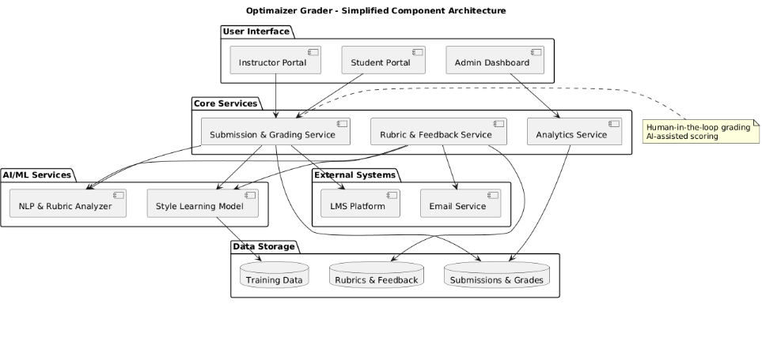
A.2 Data Flow Diagram (Level 1) Source:
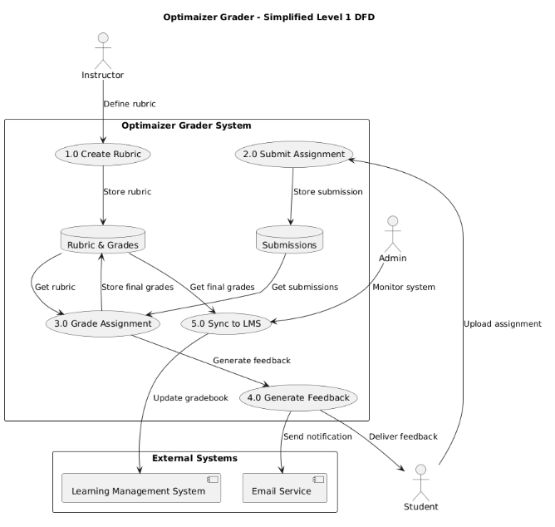
A.3 Use Case Diagram :
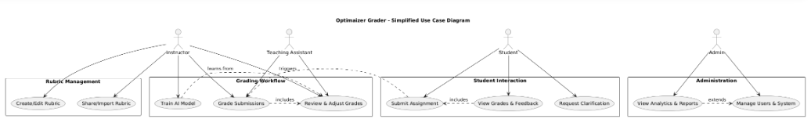
Appendix B: Rubric Templates & Examples
Table: Standard Rubric Template Structure
Component | Description | Example
Criteria | Assessment dimensions | Thesis, Evidence, Organization
Levels | Performance tiers | Excellent, Good, Fair, Poor
Descriptors | Level descriptions | "Clear thesis with strong support"
Points | Numerical values | 10, 8, 6, 4
Weight | Criterion importance | 30%, 40%, 30%
Comments | Feedback templates | "Consider adding more evidence here"
Table: Common Rubric Types
Type | Subjects | Complexity | Auto-Grade Support
Analytic | Essays, reports | High | 85% accuracy
Holistic | Creative work | Medium | 70% accuracy
Checklist | Lab reports, code | Low | 95% accuracy
Single-Point | Peer review | Medium | 80% accuracy
Weighted | Projects, portfolios | High | 75% accuracy
Appendix C: Integration Standards
Table: LMS Integration Specifications
LMS Platform | LTI Version | Grade Sync | Student Sync | Authentication
Canvas | LTI 1.3 | Real-time | Automatic | OAuth 2.0
Moodle | LTI 1.3 | 5-min delay | Manual import | OAuth 2.0
Blackboard | LTI 1.3 | Real-time | Automatic | SAML
Schoology | LTI 1.3 | 10-min delay | Automatic | OAuth 2.0
Google Classroom | API v3 | Real-time | Automatic | Google OAuth
Table: File Format Support
Format | Processing Method | Limitations | OCR Support
PDF | Text extraction | Scanned PDF requires OCR | Yes
DOC/DOCX | Direct parsing | Embedded images limited | No
TXT | Direct processing | No formatting | No
Code Files | Syntax highlighting | Language detection required | No
Images | OCR processing | Quality dependent | Yes
LaTeX | Compile to PDF | Requires LaTeX engine | No
Appendix D: Revision History
Table: Document Revision History
Version | Date | Author | Changes | Status
1.0 | 2025-10-26 | [Your Name] | Initial release | Approved
0.9 | 2025-10-20 | [Team Member] | Added sequence diagram | Reviewed
0.8 | 2025-10-15 | [Team Member] | Updated integration specs | Draft
0.7 | 2025-10-10 | [Team Member] | First complete draft | Draft

